THE ESSENCE OF REAL MEN
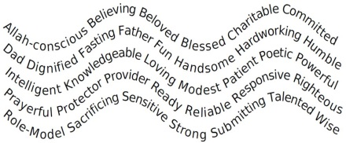
By Olaiya Humphrey

The essence of real men is that they not only fear Allah, but love Him and are aware of Him through and through.
Real men believe without seeing and are beloved by many. Even those that don’t love them can’t help but respect them.
They are blessed because they commit to
give so much without being asked.
Real dads spend time having fun with their kids and grandkids, but they also know where to draw the line between being a friend and being a father or grandfather.
Dignity is their armor. They fast for Allah without complaining.
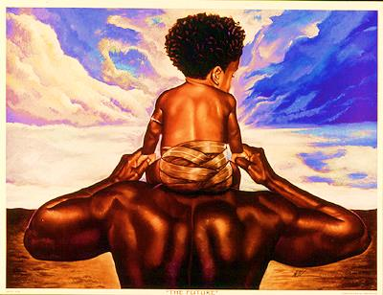
Real men are handsome not just on the outside, but on the inside too. They take care of the bodies their Creator gave them.
No one works harder than real men, and real men appreciate that real women work as hard as they do.
They are humble, not arrogant.
They are intelligent and knowledgeable because they know that knowledge is one of Allah’s greatest gifts. They’re the ones to go to when you need an answer, and they’re always looking for ways to share their knowledge.
Real men never run out of love for their families, friends, neighbors and their community.
They are modest, knowing that Allah made them beautiful too, but they’re not show offs and they preserve themselves for their special ones.
No one is more patient than real men. They spend many sleepless nights and go through so many trials, but they keep in mind that Allah doesn’t burden a person more than he has the strength to bear.
They express themselves passionately and poetically.
Real men are powerful, but not just with their muscles. They know that their greatest power comes from their ability to be self-disciplined.
They call the adhan, the iqamah, and they’re full of prayer.
Protecting and providing are natural for them, and they protect and provide for more than just their families.
Who’s ready? Real men. You can rely on them to step up and respond with righteousness.
They are our role-models, but they’re always setting good examples for others too because that’s what Allah told them to do.
Real men sacrifice. They’ll give you the shirts off their backs and even the last chicken wing if you ask for it.
They are sensitive and care about other people’s feelings, but even if they hurt somebody, they know an apology doesn’t make them any less of a man.
Real men are strong physically, mentally, spiritually, and emotionally.
Submitting to Allah’s will is what makes them do what they do. For that they are rewarded with endless talent and wisdom.
How do I know so much about what real men are? My dad’s a real man; my Muslims brothers are real men, and I’m a real man in training.
Delivered by Adam E. Moultrie, MBIR Father’s Day June 16, 2013.

